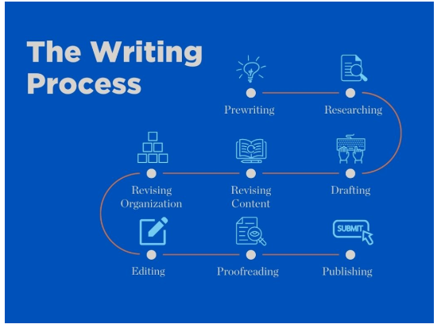

The Writing Process

Writing is a process of four general steps: inventing, drafting, revising, and editing. You might prefer to do the steps linearly, one after the other, or iteratively, in repeating or successive sessions. The steps blend into each other, so putting effort into each step pays off at the end with a clear, concise, and complete paper. The other side of this sheet defines the steps and suggests how and when to use each step.
Approximately 50% of the process consists of generating ideas and organizing them into a coherent form (the invention and drafting steps).
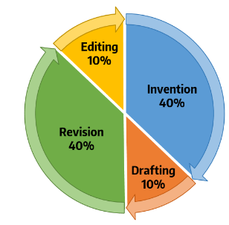
Invention, also called pre-writing or brainstorming, is the foundation of a successful paper—without it, you’ll have nothing to draft, revise, edit, or submit to your professor.
Here are some different ways to invent or begin the writing process.

• Note-taking — This can be as simple as jotting down reactions again many times.
• Listing — Write down everything you can think of that is
related to your paper topic. You can add or remove items from your list at any time.
• Free-writing — Write for 5 minutes on your topic without stopping or worrying about spelling, grammar, or anything else. If you run out of ideas about your topic, write “I don’t know what to say” or something similar until you start to come up with more ideas. Free-writing helps you clear out some of your dead-end ideas and write yourself into some surprising and fruitful ideas.
• Clustering (also called mapping or webbing) — This method allows you to show how your items or ideas are related to each other. Separate your thoughts into similar categories and draw lines connecting those categories to each other and/or to your main topic.
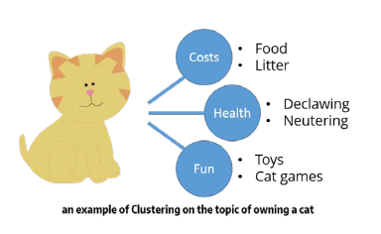
• Outlining — Outlining consists of creating headings and putting your ideas, evidence, or sources under those headings so you can clearly see the entire paper’s organization.

The other 50% of the process (the revision and editing steps) consists of looking at the ideas and form more closely, often from a reader’s perspective. All four steps consider both global issues (such as argument, focus, and structure) and local issues (such as spelling and punctuation) to some degree.

Using the Writing Process
These tables describe the four steps of the writing process: inventing, drafting, revising, and editing. Knowing when and how to use these steps will help you resolve common problems in your own writing and grow as an effective writer.

